**EX.NO:1 Creation of tables,forms,frames and links**

**DATE:06-07-15**

**AIM:**

To write a html program for creation of tables,forms,frames,links.

**ALGORITHM:**

STEP1: open the editor

STEP2: create the link that links the table.

STEP3: create the table with necessary table heads,table columns and give the name for the table.

STEP4: create the form.

STEP5: create the frames

STEP6: save the program with .htm extend.

STEP7: open the html document in internet explorer

PROGRAM:

**1.HTML(LINKS)**

<html><head>

<title> hai welcome to html pgm</title></head>

<body>

<a href="1.html"><FONT COLOR="YELLOW">CLICK HERE TO GO 3RD YEAR 5TH SEM IT SYLLABUS</FONT></a>

</body>

</html>

**OUTPUT:**

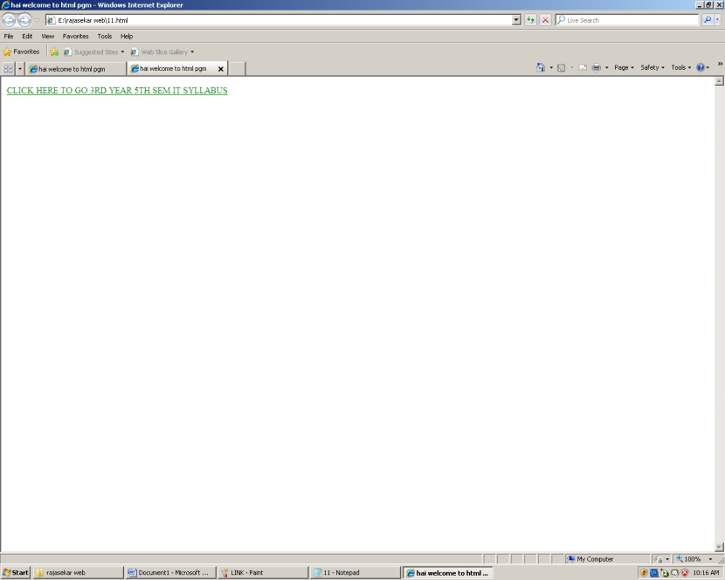

**11.html(TABLE)**

<html>

<head>

<title>form</title>

</head>

<body>

<center><h1>INFORMATION TECHNOLGY</h1>

<marquee direction="right"><h1><font color="red"> welcome to it 3rd year b section</font></h1></marquee>

<h2>5th SEM REGULATIONS2013</h2>

<table border="3" >

<tr><th colspan="3"> <h1><font color="GREEN"> 5 SEM SYLLABUS</font></h1></th></tr>

<tr> <th> SUB.NAME</th><th>SUB.CODE</th><th>CREDITS</th></tr>

<tr><th><input type="text" value=WEBPROGRAMMING></th>

<th><input type="text"></th>

<th><input type="text"></th></tr>

</tr><th><input type="text" value=GRAPHICSANDMUTLIMEDIA></th>

<th><input type="text"></th>

<th><input type="text"></th></tr>

<tr><th><input type="text" value=WIRELESSCOMMUNICATION></th>

<th><input type="text"></th>

<th><input type="text"></th></tr>

<tr><th><input type="text" value=COMPUTERNETWORKS></th>

<th><input type="text"></th>

<th><input type="text"></th></tr>

<tr><th><input type="text" value=DIGITALSIGNALPROCESSING></th>

<th><input type="text"></th>

<th><input type="text"></th></tr>

<tr><th><input type="text" value=OBJECTORIENTEDANALAYSISANDDESIGN></th>

<th><input type="text"></th>

<th><input type="text"></th></tr>

<tr><th><input type="text" value=OOADLAB></th>

<th><input type="text"></th>

<th><input type="text"></th></tr>

<tr><th><input type="text" value=CNLAB></th>

<th><input type="text"></th>

<th><input type="text"></th></tr>

<tr><th><input type="text" value=WEBLAB></th>

<th><input type="text"></th>

<th><input type="text"></th></tr>

**OUTPUT:**

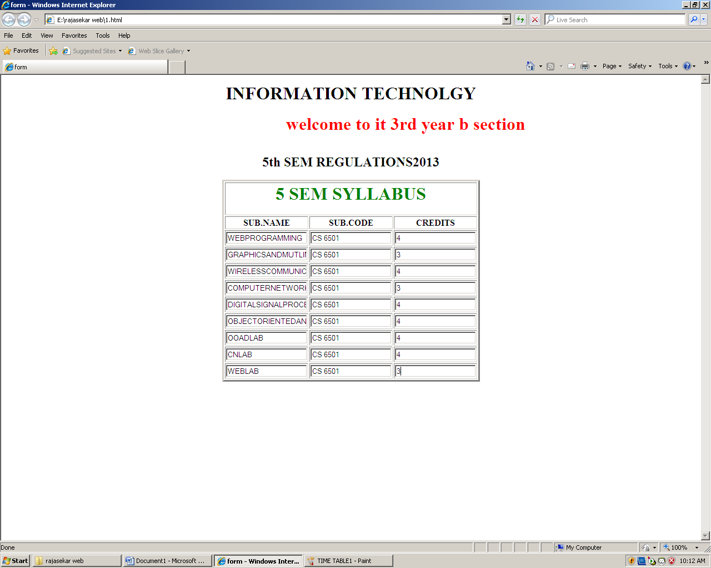

**FRAMES:**

<html>

<frameset cols="30%,70">

< frame src="1.html">

<frame src="11.html">

</frameset>

</html>

**OUTPUT:**

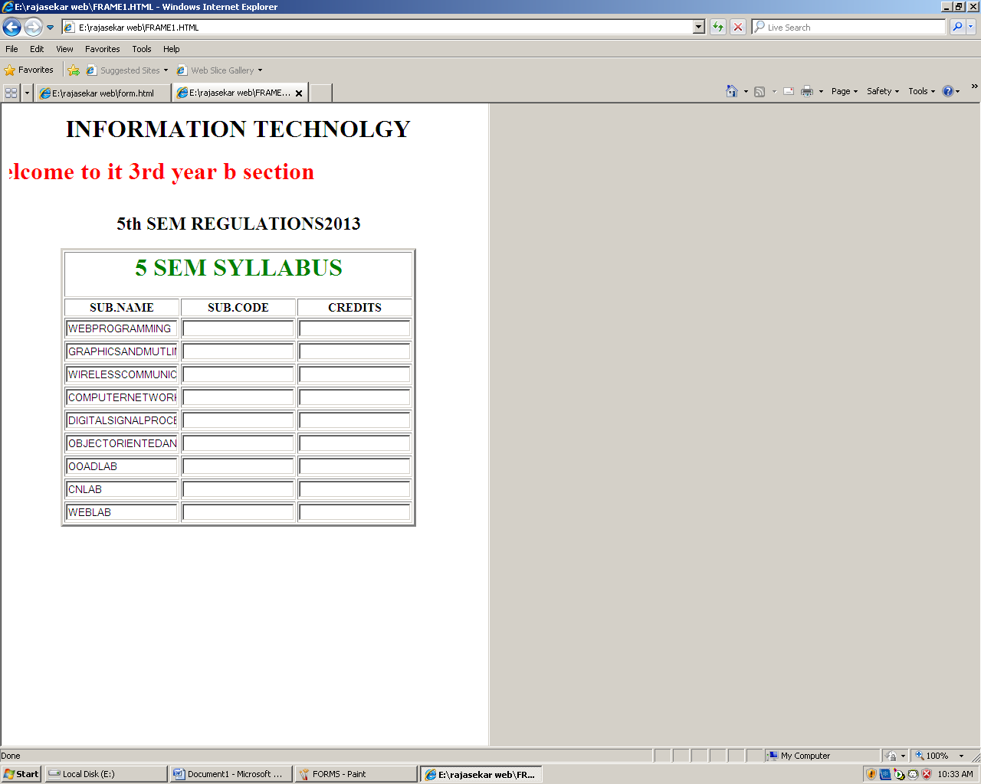

**FORMS**

<form>

username:

<input type="text" name="username">

<br>

password:

<input type="password" name="password">

<br>

gender:

<input type="radio" name=sex value="male">male

<input type="radio" name=sex value="female">female

<br>

address:

<textarea name="addr" rows="3" cols="30"></textarea><br>

what is ur hobby<br>

<input type="checkbox" name="thanthi">daily thanthi<br>

<input type="checkbox" name="exp">hindu express<br>

<input type="checkbox" name=" o">others<br>

qualification:

<select name="qualifcation">

<option value="ug">under graduate

<option value="pg">post graduate

<option value="others">other graduate

</select>

<p>

a moving iamge:

<img src=sunset.jpg width="40" height="45"></p>

</form>

**OUTPUT:**

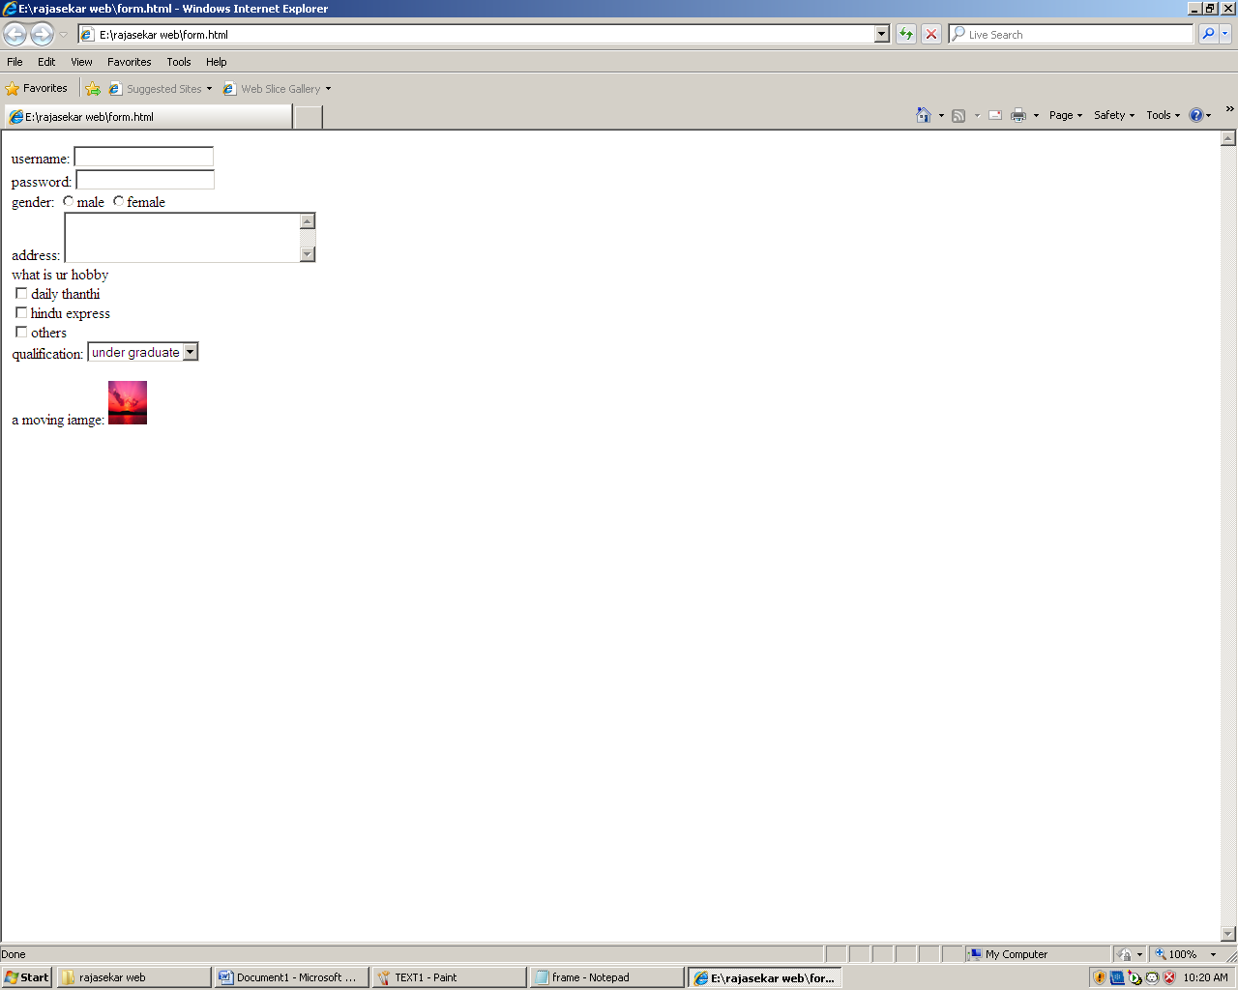

**EX.NO:2 BASIC TEXT FORMATTING**

**DATE:13-07-15**

**AIM:**

To design a website using basic text formatting.

**ALGORITHM:**

STEP1: open the editor.

STEP2: start the html document with necessary title.

STEP3: create the strong,bold,emphasized,small and big text.

STEP4: save the html program with .htm extension.

STEP5: open the html document in internet explorer.

**PROGRAM:**

<html>

<body background="blue hills.jpg"></body>

<title>TEXT FORMATTING</title>

<body>

<b>this is bold text</b>

<br>

<i>this is italic</i>

<br>

<strong>

this is strong text</strong>

<br>

<em>

this is emphasized text</em>

<br>

<big>

this is big txt</big>

<br>

<small>

this is small text</small>

<br>

this text contains

<sub>

subscript

</sub>

<br>

this text contains<sup>

superscript

</sup>

<pre>

this is preformatted text

it preserves both spaces and line breaks

</pre</body>

**OUTPUT:**

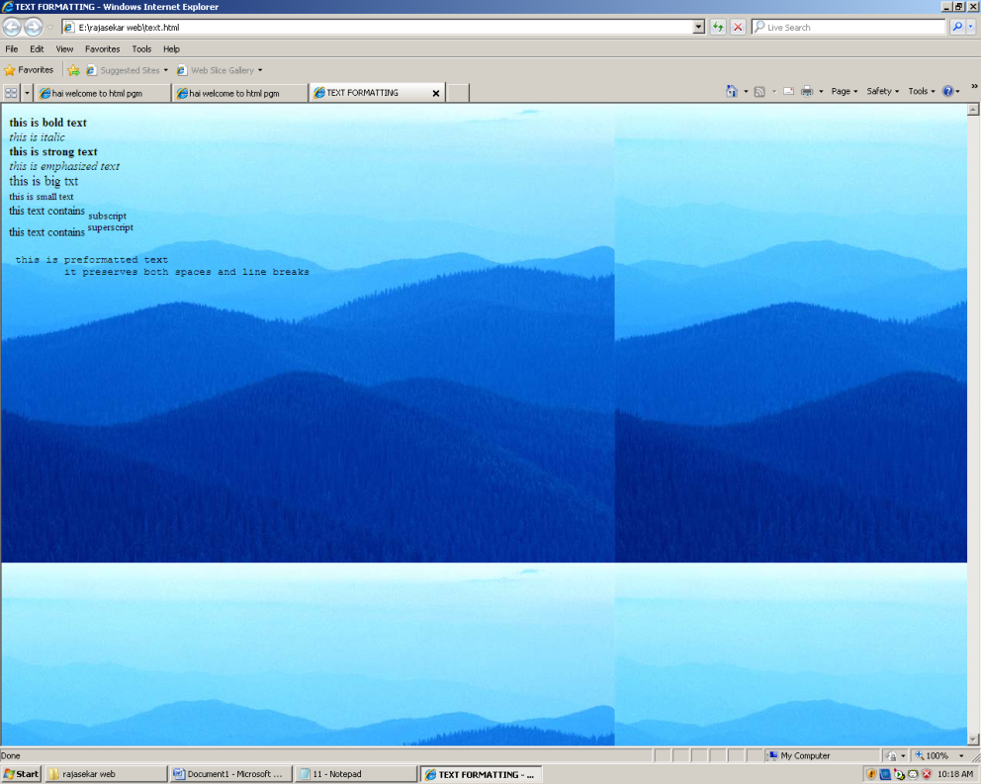

**EX.NO 3: CREATION OF SCRIPTS THAT ASKS USER NAME AND GREETS THE USER**

**DATE20-07-15**

**AIM:**

Creating the script that asks the user for name and greets the user with hello.

**ALGORITHM:**

STEP1: open the editor

STEP2: create the script with title.

STEP3: Get the variable for confirms the username.

STEP4: if username is valid print hello user

else print invalid .. try again.

STEP5: save the html document with .htm extension

STEP6: open the html document in internet explorer.

**PROGRAM:**

<html><head>

<title>javascipt example</title>

<script>

var username=prompt("enter yr name","");

if(confirm("yourname is" + username))

{

document.write("your name is and welcome" + username +"|</p>");

}

else

{

document.write("<p>hello world|</p>");

}

</script></head>

<body>

<p>welcome to script</p>

</body>

</html>

**OUTPUT:**

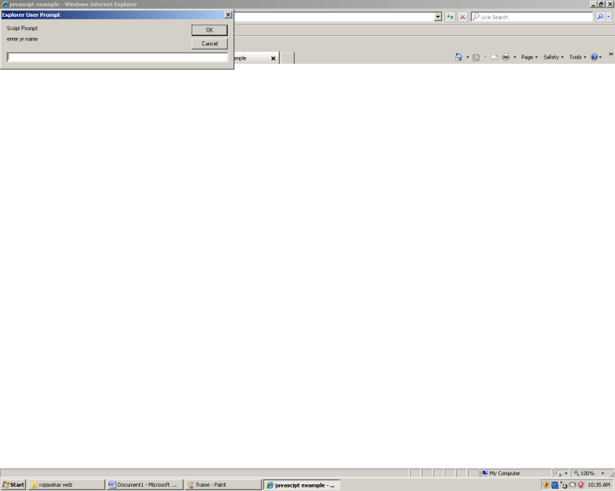

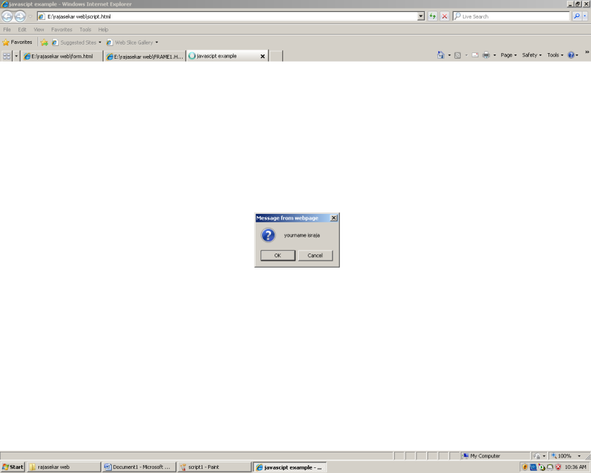

**EX NO: 4** **ADDING TWO NUMBER USING JAVASCRIPT**

**DATE:27-07-15**

AIM:

To create addition program in add two value using Javascript.

ALGORITHM:

Step1: Open notepad.

Step2: Type the addition program.

Step3: Using add function , click button.

Step4: To go to browser in output view.

Step5: Save in .html extension.

Step6: Close the notepad.

**PROGRAM:**

<html>

<head>

<script>

function ram()

{

var a1=parseInt(f1.t1.value)+parseInt(f1.t2.value);

document.write("Answer is:"+a1);

}

</script>

</head>

<body>

<form name="f1">

<pre>

Enter the first value: <input type="text" name=t1>

Enter the second value:<input type="text" name=t2>

Result:<input type="button" value="Go" onclick="ram()">

</pre>

</form>

</body>

</html>

OUTPUT:

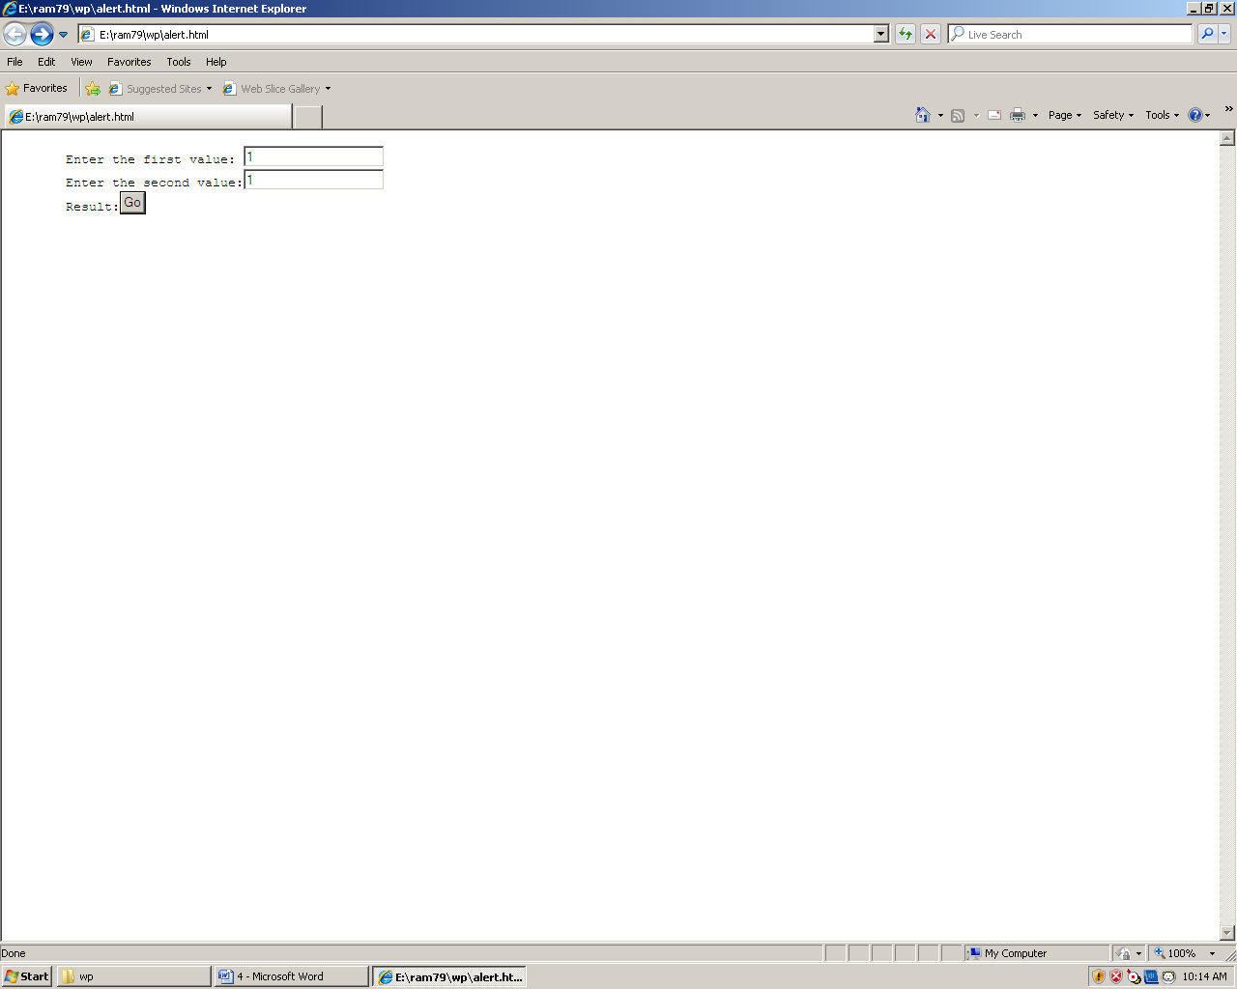

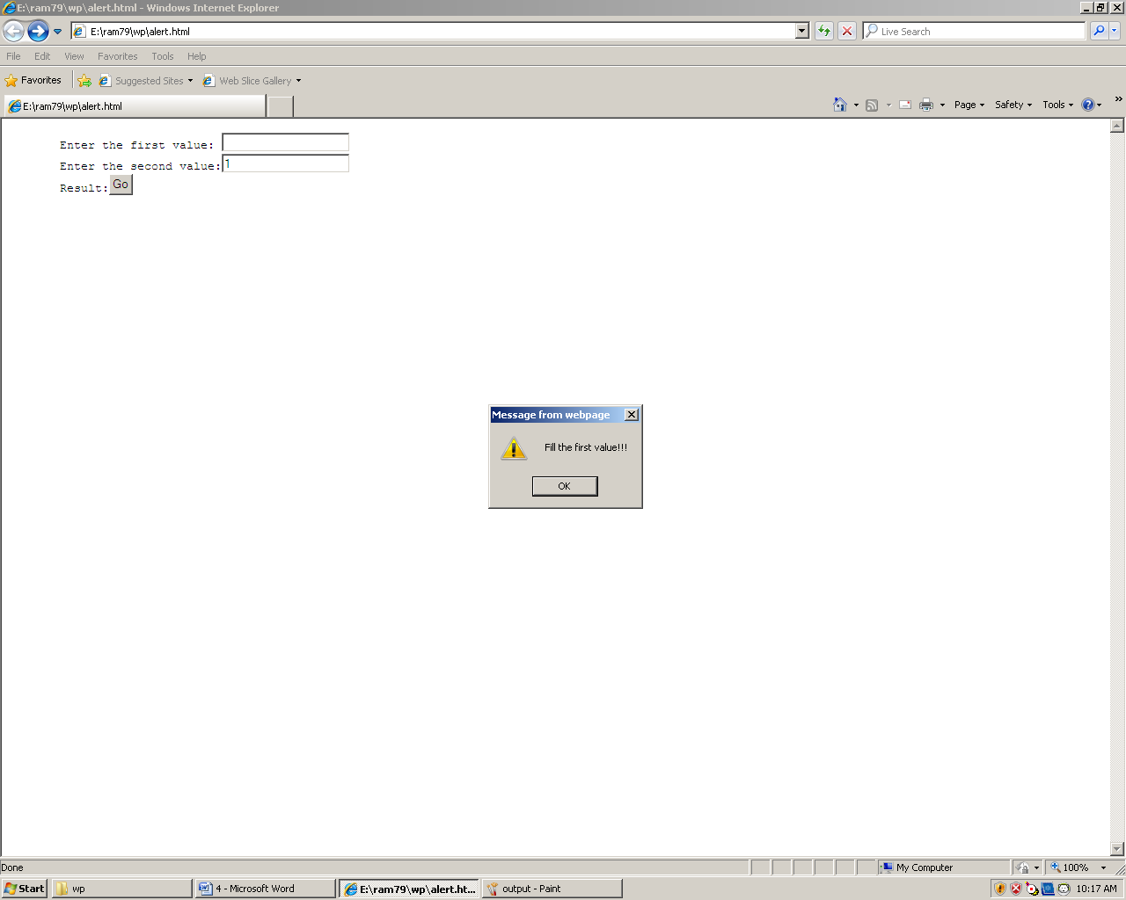

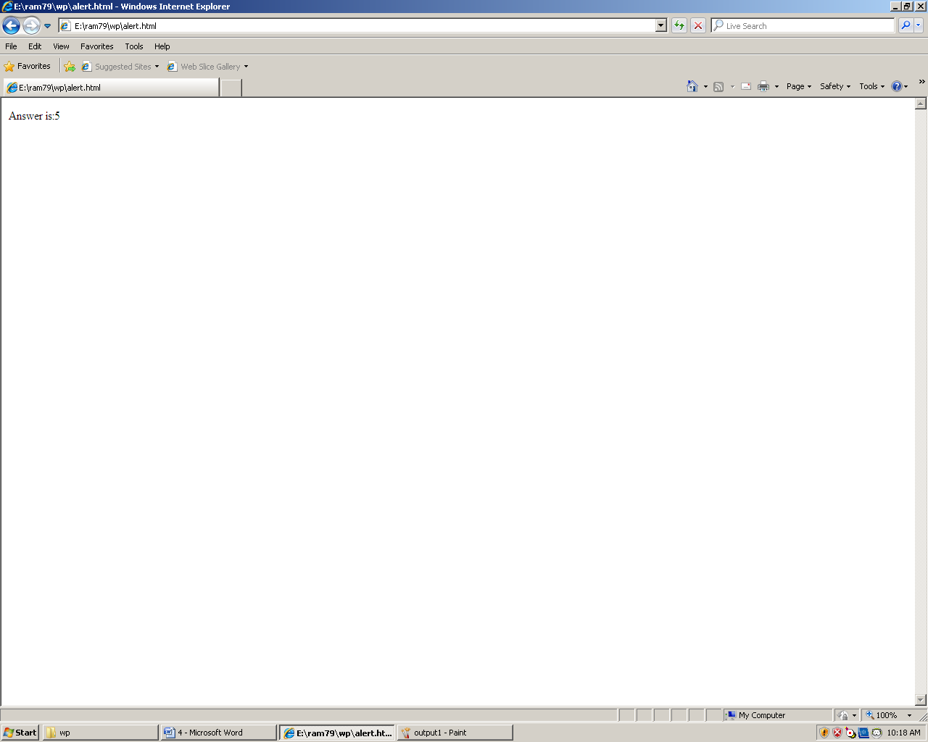

EX NO: 5 FIND ODD NUMBER USING PROMPT

DATE:03-08-15

AIM:

To create odd program using Prompt.

ALGORITHM:

Step1: Open notepad.

Step2: Type the integer number in prompt.

Step3: And click the OK button.

Step4 To view the odd number in ‘0’ to your int number.

Step5: Close the notepad.

PROGRAM:

<html>

<head>

<script>

var a=prompt("Enter the first value");

var b=prompt("Enter the second value");

var c=parseInt(a)+parseInt(b);

prompt(c);

</script>

</head>

<body>

<form name="f1">

<pre>

</pre>

</form>

</body>

</html>

**OUTPUT:**

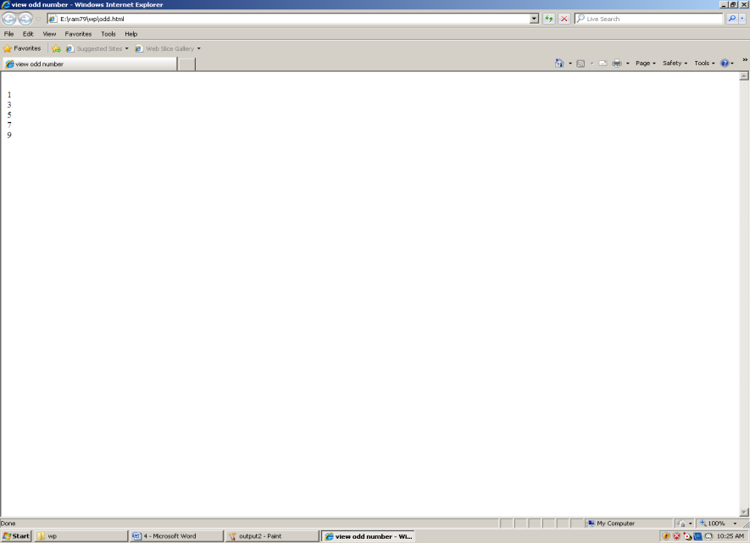

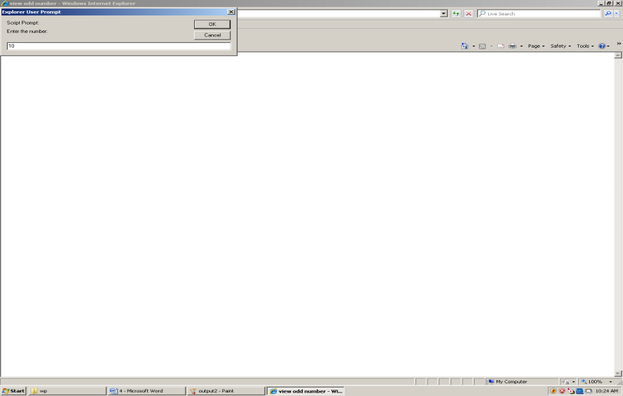

# EX.NO:6 ALERT MESSAGE FOR USER

**DATE:03-08-15**

**AIM:**

TO WRITE A PROGRAM ALERT MESSAGE THE USER IF IT IS BLANK FILED USING JAVA SCRIPT

**ALGORITHM:**

STEP1: Open the editor

STEP2: create the html document with necessary title.

STEP3: create the java script to alert message to user for blank field.

STEP4:save the program in .htm extend

STEP5: open the html document in internet explorer.

**PROGRAM:**

<html>

<head>

<script>

function add()

{

if(f1.t1.value=="")

{

alert("fill the first value!!!");

}

else if(f1.t2.value=="")

{

alert("fill the second value!!!");

}

else

{

var a1=parseInt(f1.t1.value)+parseInt(f1.t2.value);

document.write("add the value is:"+a1);

}

}

</script>

</head>

<body>

<form name="f1">

<pre>

enter the 1st value:<input type="text" name=t1>

enter 2nd value:<input type="text "name=t2>

result:<input type="button" value="go"onclick="add()">

</pre>

</form>

</body>

</html>

**OUTPUT:**

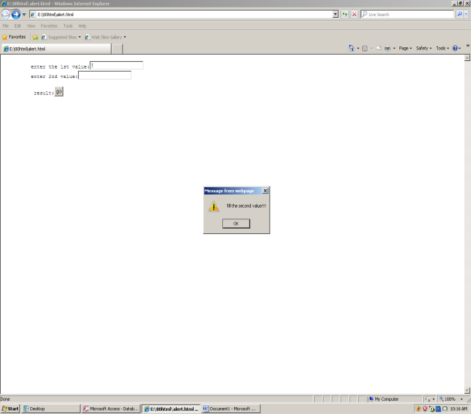

**EX.NO:7 USING CSS FOR CREATE WEBSITES**

**DATE:**

AIM:

TO Create a webpage using css with tables links forms

ALGORITHM:

STEP1: open the editor

STEP2: create the external css.

STEP3:create the internal css by using style tag.

STEP4: create the table,forms,frams etc

STEP5:save the file in .htm extend.

STEP6:open the html document in internet explorer.

PROGRAM:

<html>

<head>

<link rel="stylesheet" type="text/css" href="cascade.css">

<title>tutorial class</title>

</head>

<body>

<marquee>

<h1>welcome</h1>

</marquee><br>

<p>our class is located in neivanai</p><br>

<a href=www.raj.com>our website</a>our working days

<table border="3" border color="blue" cellspadding="32" cellspacing="33">

<tr>

<th>

day

</th>

<th>working hours</th>

</tr>

<tr>

<td>sunday</td>

<td>10am-12 am</td>

</tr>

</table>

contact

<p class="one">

call no:123456789

<br>

ph:04146777

<br>

Email:raj@gmail.com

<br>

</p>

our branches

<ul class="a">

<li>nellai</li>

<li>neivanai</li>

</ul>

<head>

<style>

body

{

background-color:violet;

font-family:"times new roman",times,series;}

h1

{

color:green;

text-align:center;

font-style:normal;

}

p.one

{

border-style:solid;

border-color:green;

}

a

{

color:blue;

}

body

{

outline-style:solid;

outline-color:black;

}

ul.a

{

list-style-type:circle;

}

ul.b

{

list-style-type:square

}

table th,td

{

border:1px solidgreen;

}

th

{

background-colr:green;

color:blue;

}

</style>

</head>

</html>

**OUTPUT:**

